 Holiday Catalog Tic Tac Toe 

Tic Tac Toe! 3 in a row! Who wants to win a prize?
Purchase products….earn FREE Prizes!

- Download the Tic Tac Toe board.
- Order the products found on the board from my online store or directly from me.
- Make an X through the product(s) you ordered and note the date you ordered it directly on the square.
- Complete any 3 squares in a row (diagonally counts) and return your Tic Tac Toe board to me to receive your prize.
- OR Complete the ENTIRE card to receive the grand prize!

3 in a row prize:
A package of 24 Foil Snowflakes

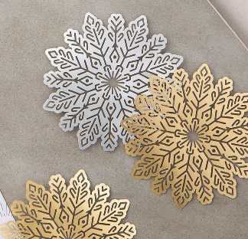
Grand Prize:
24 Foil Snowflakes, roll of Real Red 1/8” Ribbon, Black Rhinestone Jewels
and 8 Mini Pizza Boxes

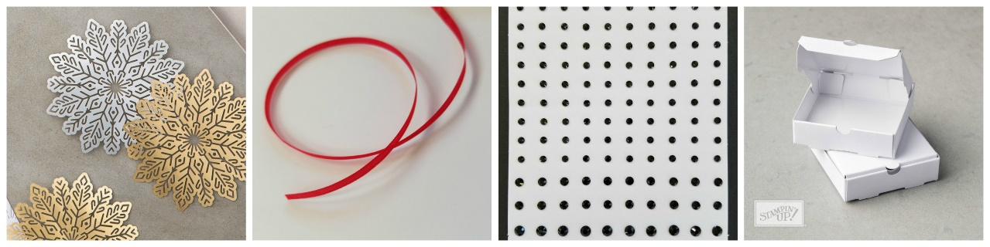

Fine print:
- Valid only for orders placed with Cindy Russell
- Completed game cards must be returned to me by mail or scanned and emailed by November 4th
- Mail to:
Cindy Russell
1640 Mountain Maple Ave.
Highlands Ranch, CO 80129
- Email to: cindy@stampbystampcreations.com

